QUOTATION SCREEN

Step 1 - Click on quote in the left side menu

Step 2 – Click Quotation -> Quote list will be displayed

Step3 – Click new ( **+** ) button -> to create new quote ->below page displayed

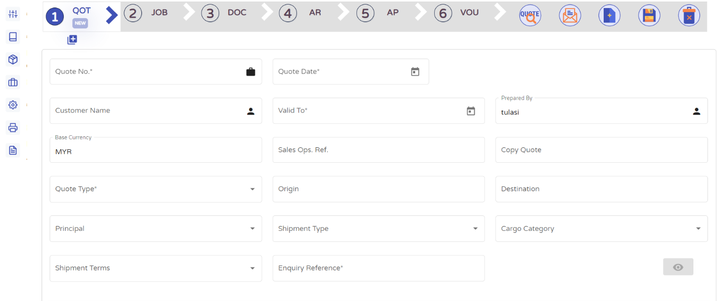

Step4 - This is the parent section -> Fill all mandatory fields to save Quote.

Step 4.1 – Copy Quote – copy from existing quote

Attach image

Step5 – Under the Child section we can add Rate, Commodity and route details by click add button (**+**)

Step6 – After entering all details click on **save** (Green tick mark) to save.

Step7 – **Route** detail is optional

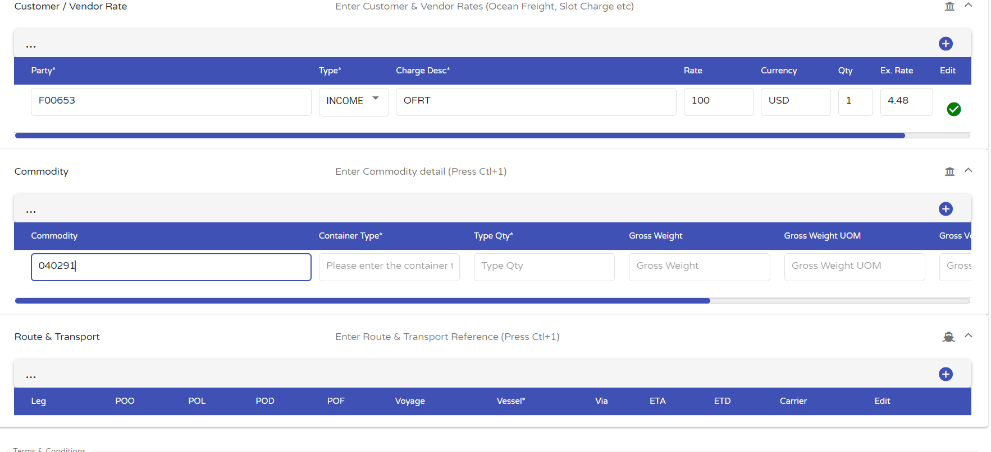

Step8 –**Terms & Conditions** – We can add T&C

Step 8.1 – edit details and save delete the data and copy from above details

Attach image

Step9 – Click on the Save button in the header to **save** the Quotation.

Step10 - To Convert job from quote in header click on (**+**) button near to the quotation number

Step11 – To convert Quote from Job system ask the **approval** from admin.

Step12 – Email – in the Header we have **Email** button – we can send an email using this button – Enter email id and click on send mail button.

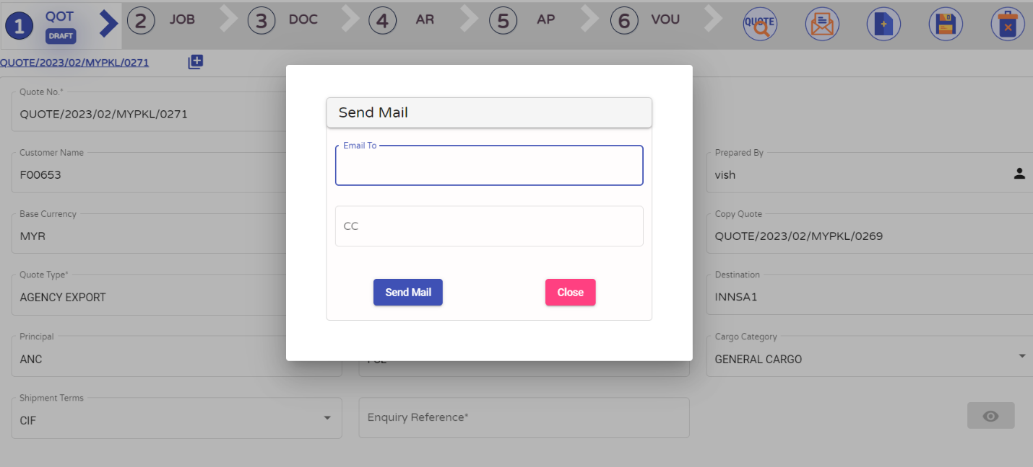

Step 12- Quote Preview – We can **preview quote in pdf** by click the button (Quote) magnifying glass in the header.

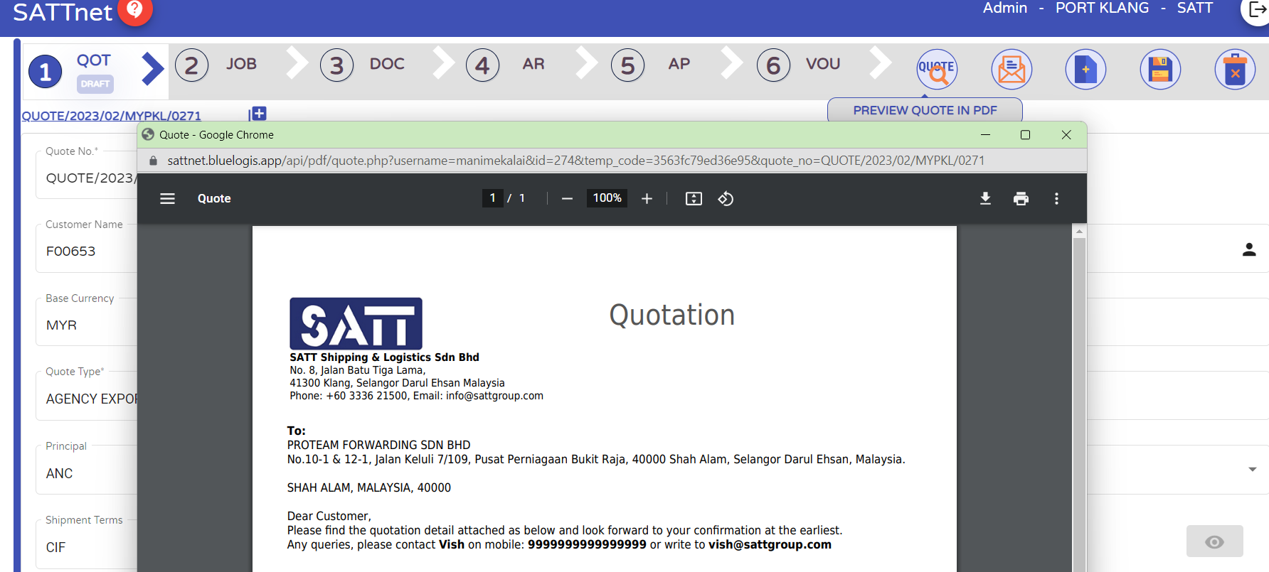

Step13 – Approval process – Admin user alone having the option to approve the quote to proceed further.

Approver can select particular quote and click the (eye icon) to approve quote.

Approval image need to attach’